**DAILY ONLINE ACTIVITIES SUMMARY**

|  |  |  |  |  |  |  |  |
| --- | --- | --- | --- | --- | --- | --- | --- |
| **Date:** | **23-6-2020** | | | | **Name:** | **K Manasa** | |
| **Sem & Sec** | **8th sem A sec** | | | | **USN:** | **4al16cs043** | |
| **Online Test Summary** | | | | | | | |
| **Subject** | |  | | | | | |
| **Max. Marks** | |  | | **Score** | |  | |
| **Certification Course Summary** | | | | | | | |
| **Course** | **Introduction to cyber security** | | | | | | |
| **Certificate Provider** | | | **Great learning academy** | **Duration** | | | **5.5hr** |
| **Coding Challenges** | | | | | | | |
| **Problem Statement:**  1.**Python program to check character is vowel or consonant** | | | | | | | |
| **Status:completed** | | | | | | | |
| **Uploaded the report in Github** | | | | **yes** | | | |
| **If yes Repository name** | | | | **Manasa** | | | |
| **Uploaded the report in slack** | | | | **yes** | | | |

**Online test**

**----------not conducted -----------**

**Certification course**

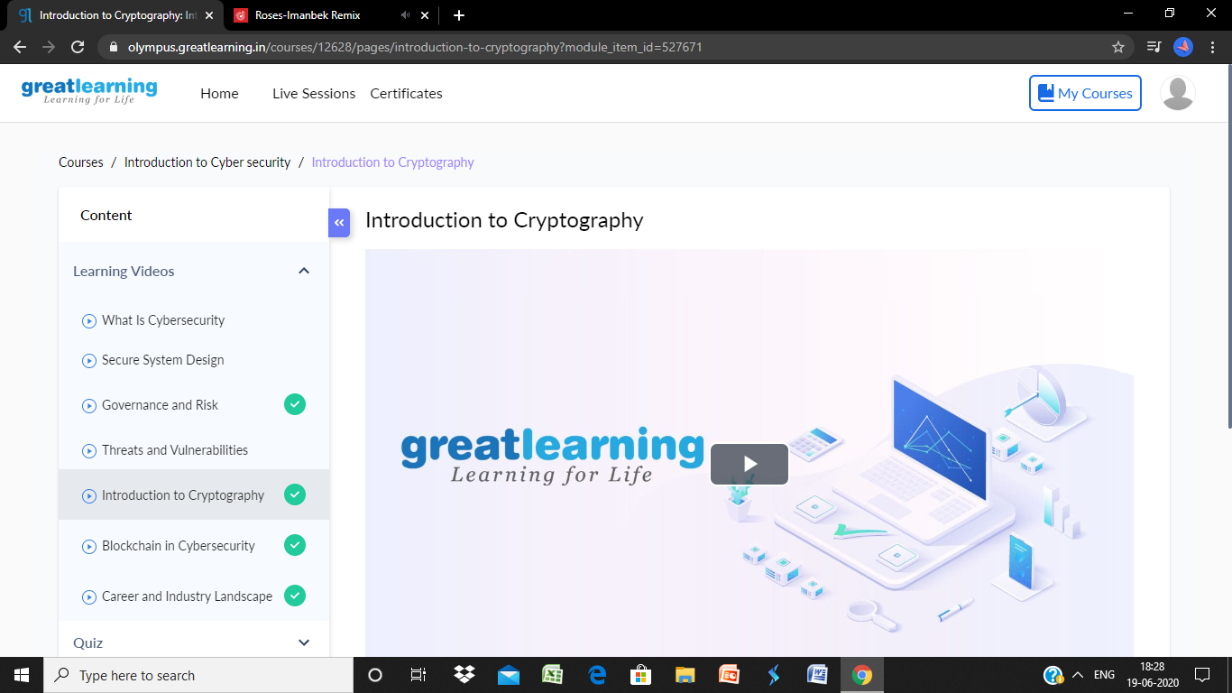

**Coding**

**Program 1**

Char = input()

if (Char == 'a' or Char == 'e' or Char == 'i' or Char == 'o' or Char == 'u'):

#if true

print("Character is Vowel")

else:

#if false

print("Character is Consonant")